Q1.create table
Query:
create table employee1(
emp_id varchar(20)primary key,
emp_name varchar(50),
dept varchar(40),
salary int);
Screenshot:
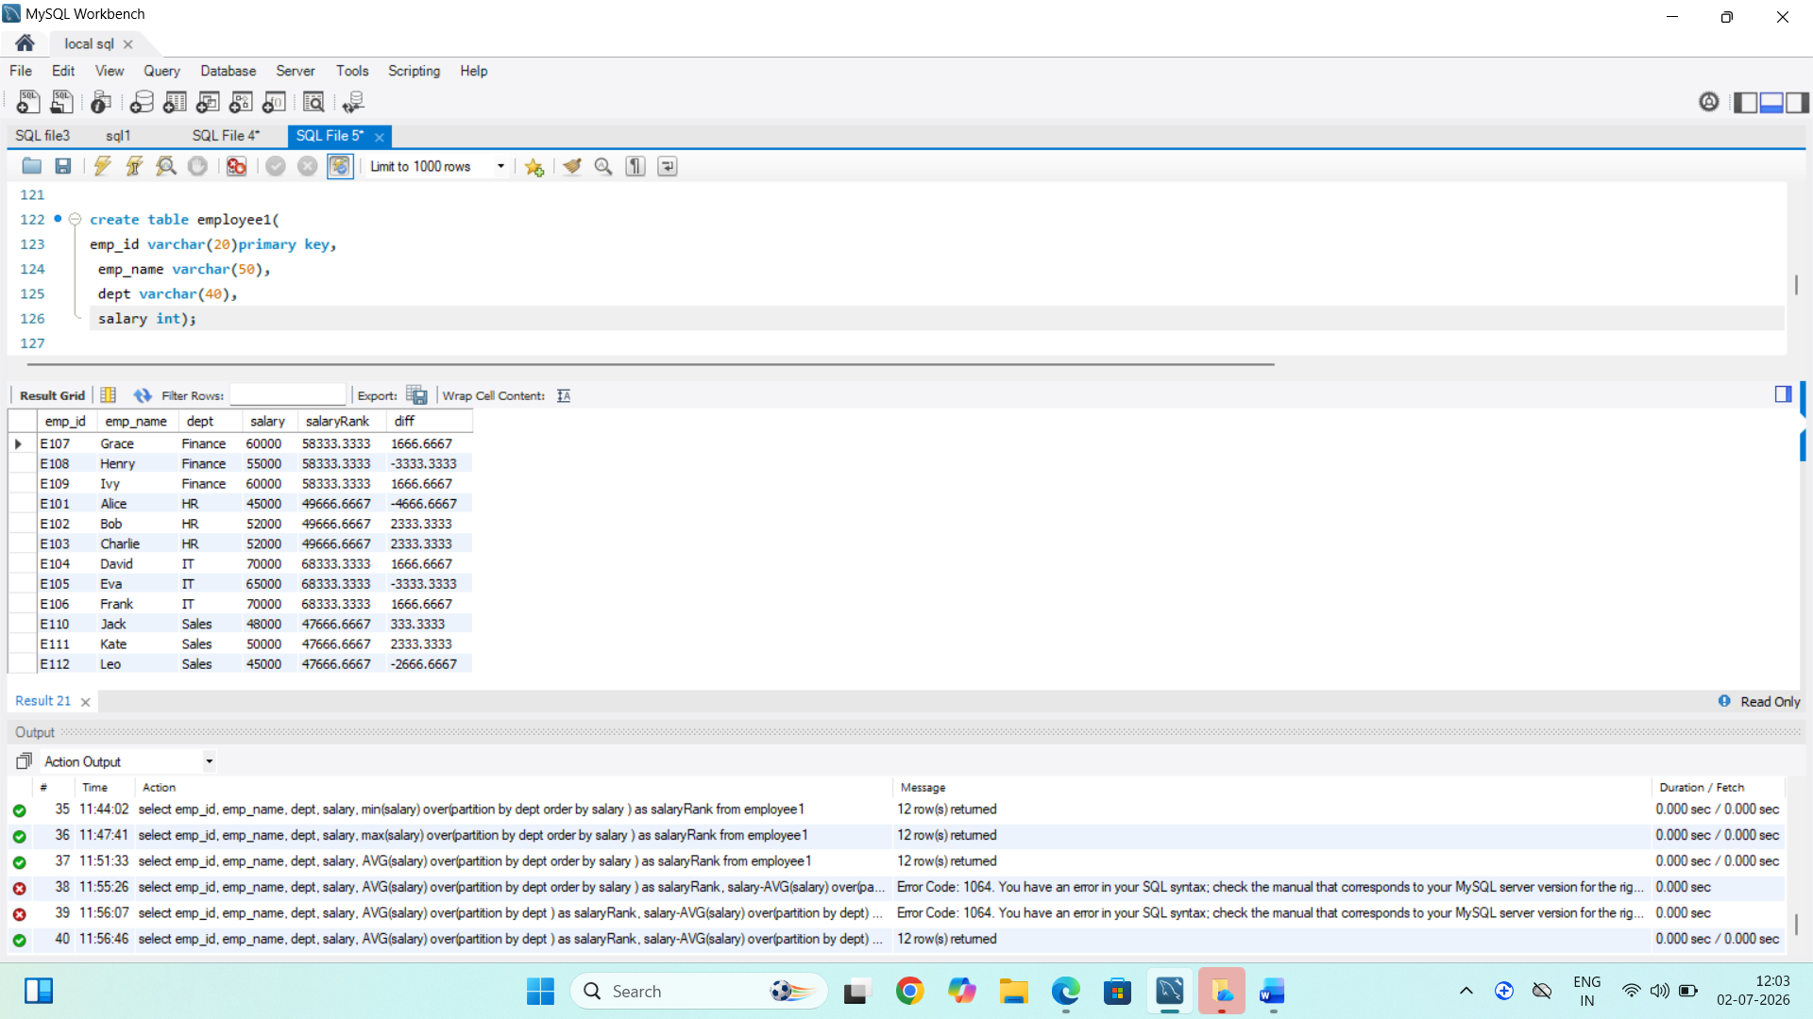

Q2.insert table
Query:
INSERT INTO employee1 (emp_id, emp_name, dept, salary) VALUES
('E101', 'Alice', 'HR', 45000),
('E102', 'Bob', 'HR', 52000),
('E103', 'Charlie', 'HR', 52000),
('E104', 'David', 'IT', 70000),
('E105', 'Eva', 'IT', 65000),
('E106', 'Frank', 'IT', 70000),
('E107', 'Grace', 'Finance', 60000),
('E108', 'Henry', 'Finance', 55000),
('E109', 'Ivy', 'Finance', 60000),
('E110', 'Jack', 'Sales', 48000),
('E111', 'Kate', 'Sales', 50000),
('E112', 'Leo', 'Sales', 45000);
select * from employee1;
Screenshot:
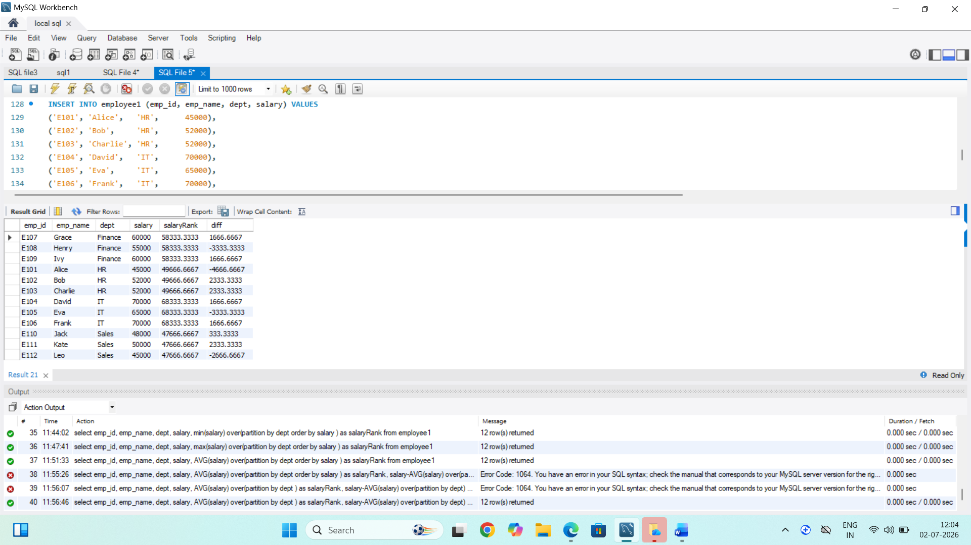

Q3.Rank()
Query:
select emp_id,
emp_name,
salary,
rank() over(order by salary desc)as salaryRank
from employee1;
Screenshot:

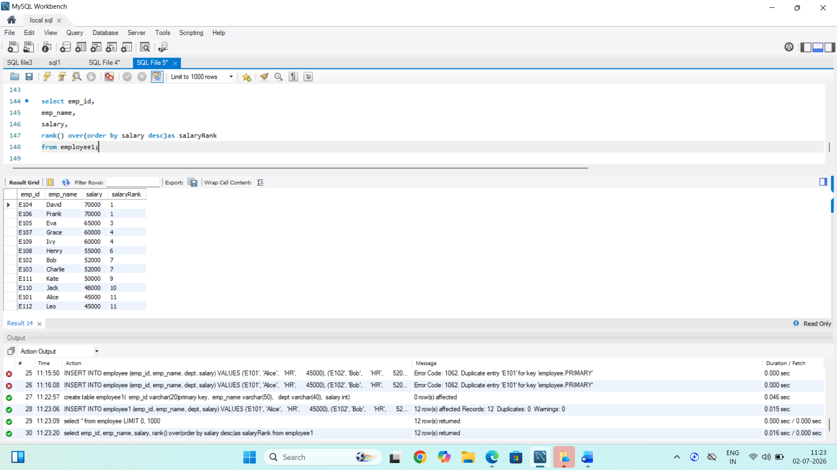
Insights:
1.rank() assigns a rank to employee based on their salary.
2. salaryrank is an alias for the rank column.

Q.4 row()
Query:
select emp_id,
emp_name,
salary,
row_number() over(order by salary desc)as salaryRank
from employee1;
Screenshot:

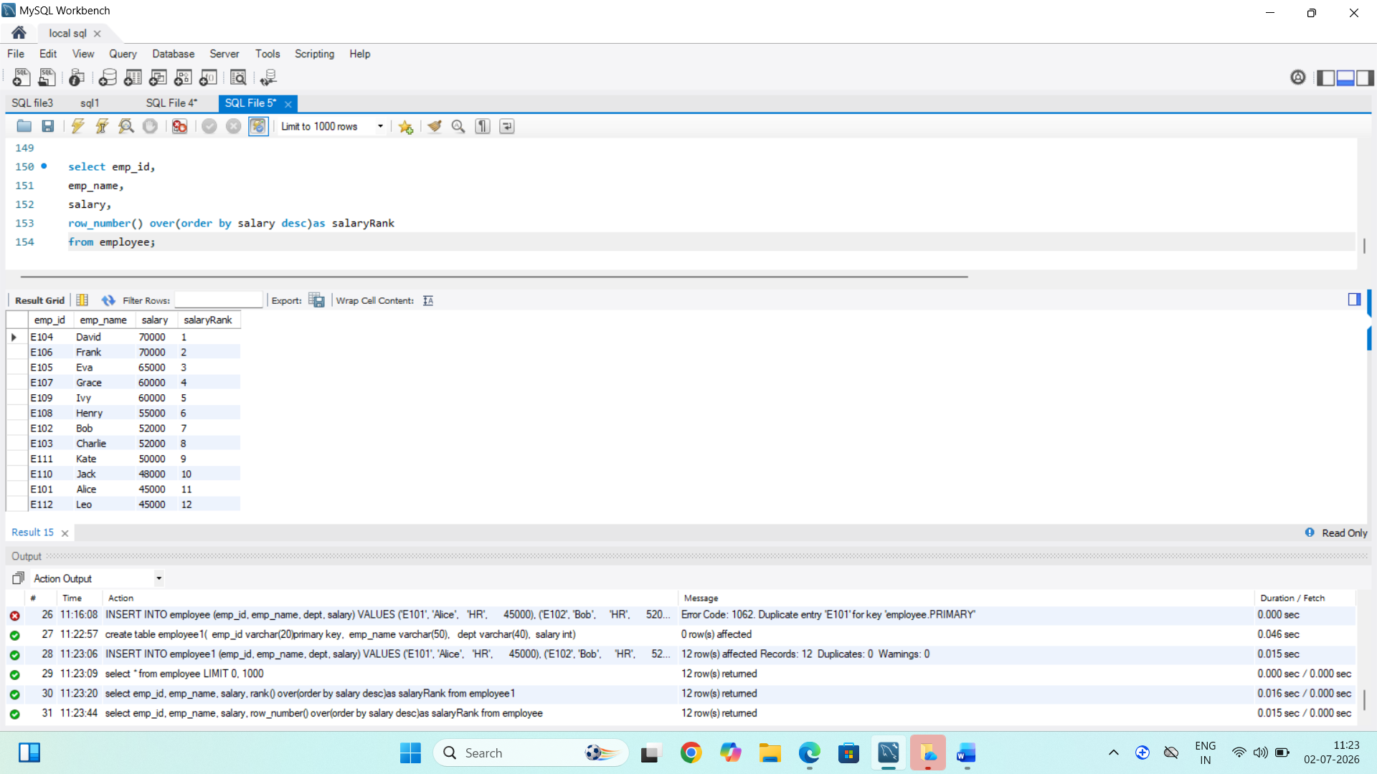
Insights:
1. row_number () is assigns unique number to each employee.
2. helps the display employee in salary order.

Q5.dense rank()
Query:
select emp_id,
emp_name,
salary,
dense_rank() over(order by salary desc)as salaryRank
from employee1;
Screenshot:

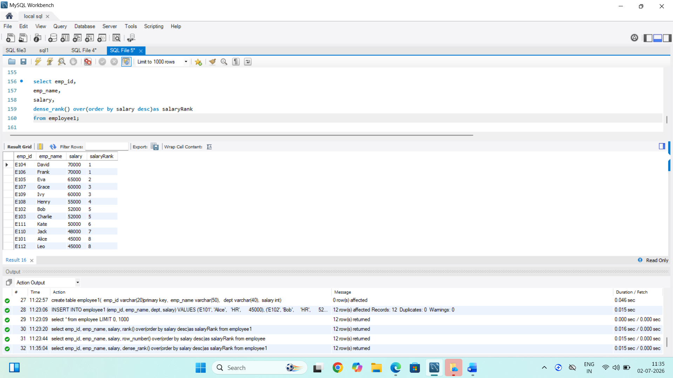

Q6.sum function()
Query:
select emp_id,
emp_name,
dept,
salary,
sum(salary) over(partition by dept order by salary desc) as salaryRank
from employee1;
Screenshot:

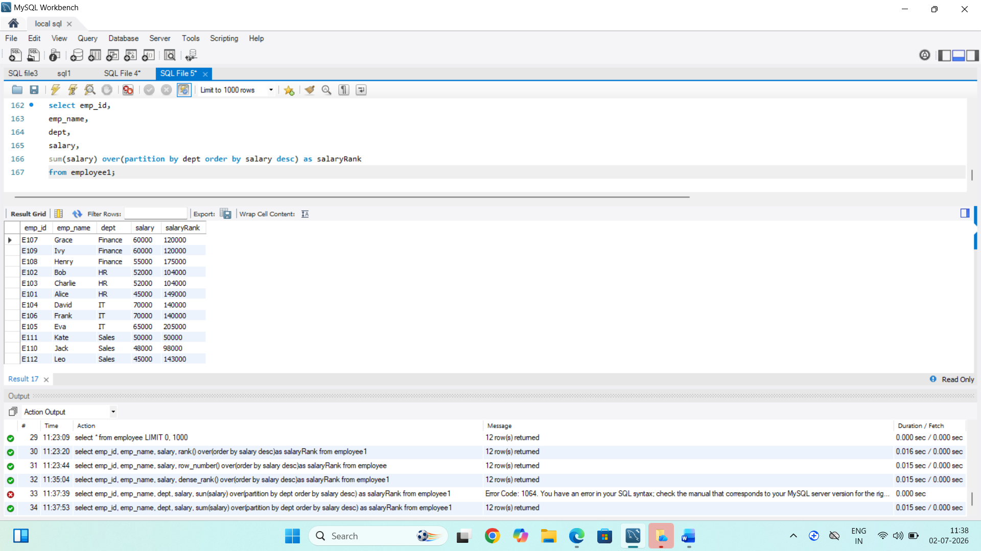

Q7.min()
Query:
select emp_id,
emp_name,
dept,
salary,
min(salary) over(partition by dept order by salary ) as salaryRank
from employee1;
Screenshot:

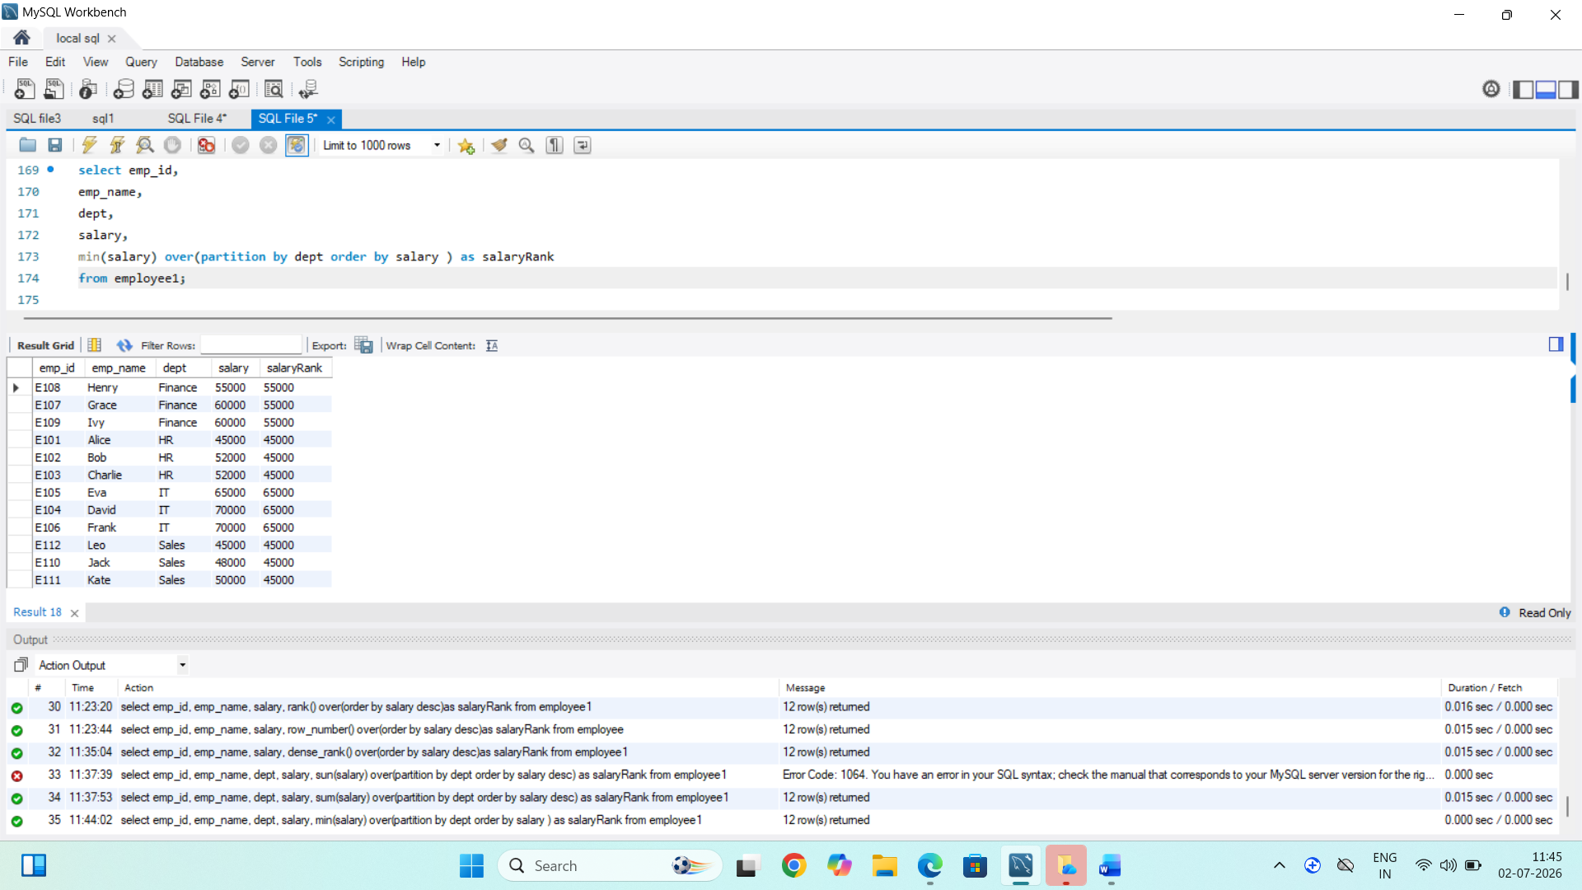

Q8.max()
Query:
select emp_id,
emp_name,
dept,
salary,
max(salary) over(partition by dept order by salary ) as salaryRank
from employee1;

Screenshot:
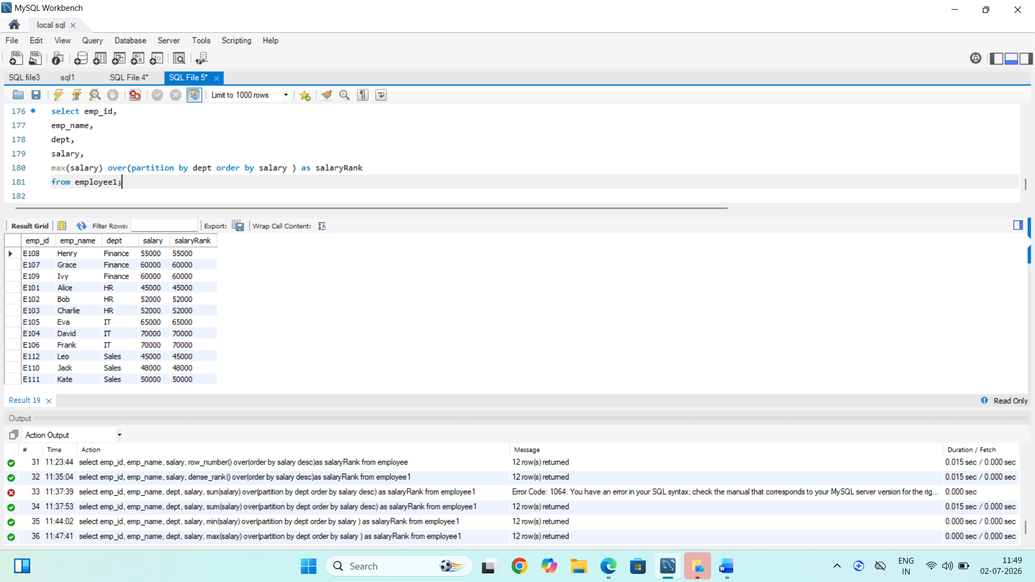

Q9.AVG()
Query:
select emp_id,
emp_name,
dept,
salary,
AVG(salary) over(partition by dept ) as salaryRank,
from employee1;
Screenshot:

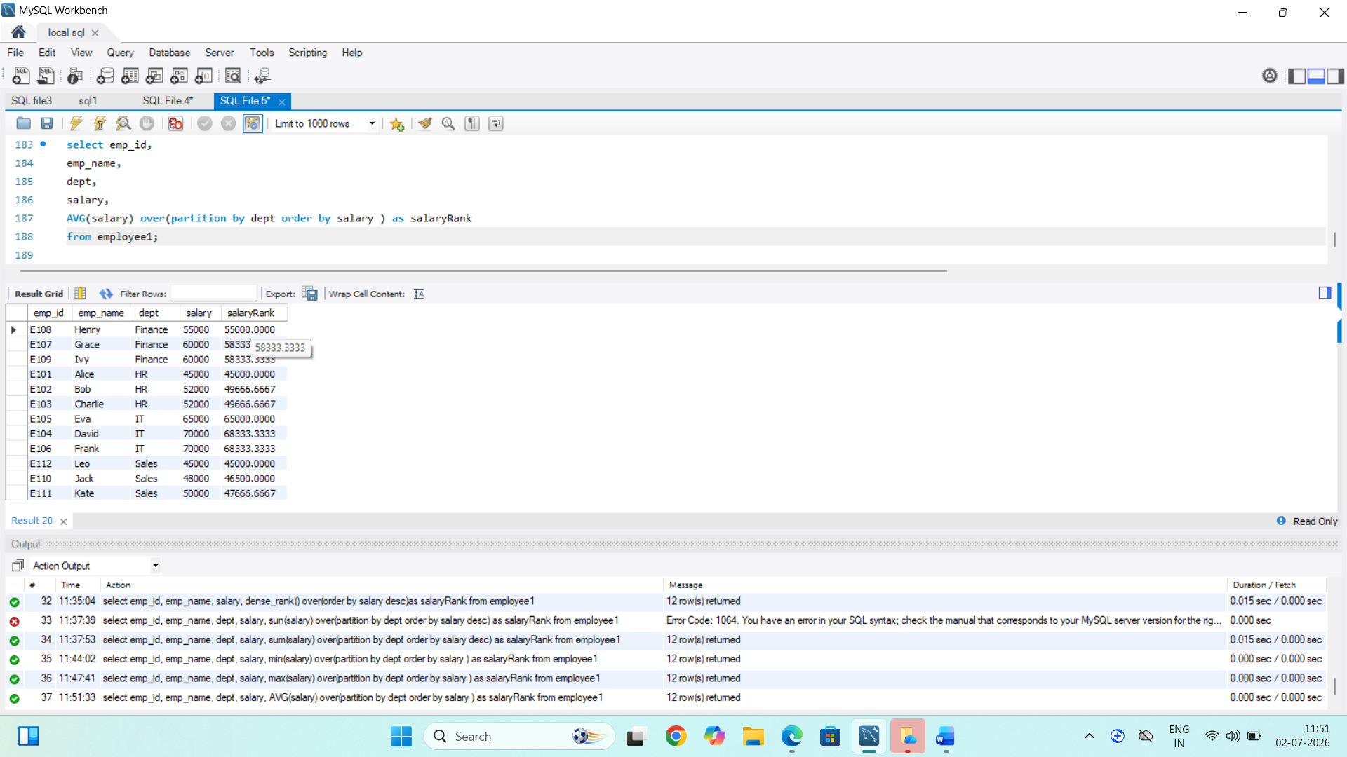

Q10.AVG salary diff()
Query:
elect emp_id,
emp_name,
dept,
salary,
AVG(salary) over(partition by dept ) as salaryRank,
salary-AVG(salary) over(partition by dept) as diff
from employee1;
Screenshot:

